How to Access TEAMS and Join Meetings

Getting Your Child Logged Into TEAMS
- If you do not have TEAMS on your computer you will need to begin by going to the GRETNA SCHOOL HOMEPAGE – https://ges.blsd.ca/.
- In the grey area below the school information you will find many tabs. You will see the REMOTE LEARNING tab. Please click on it to take you to the resources for remote learning.
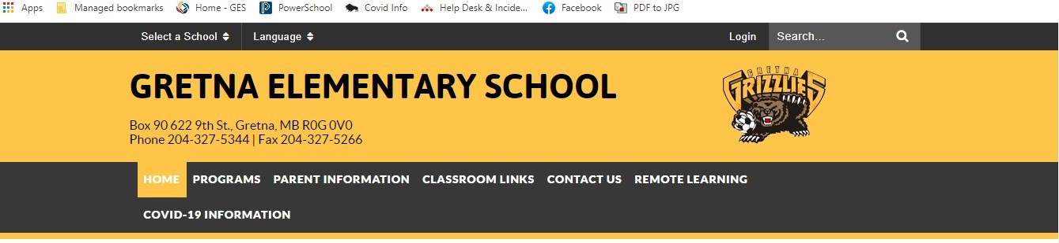
- On this page you will see the Office365 Login – please click on this link.
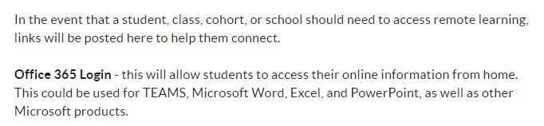
- You will now see the Microsoft Login page. Click on the red login button
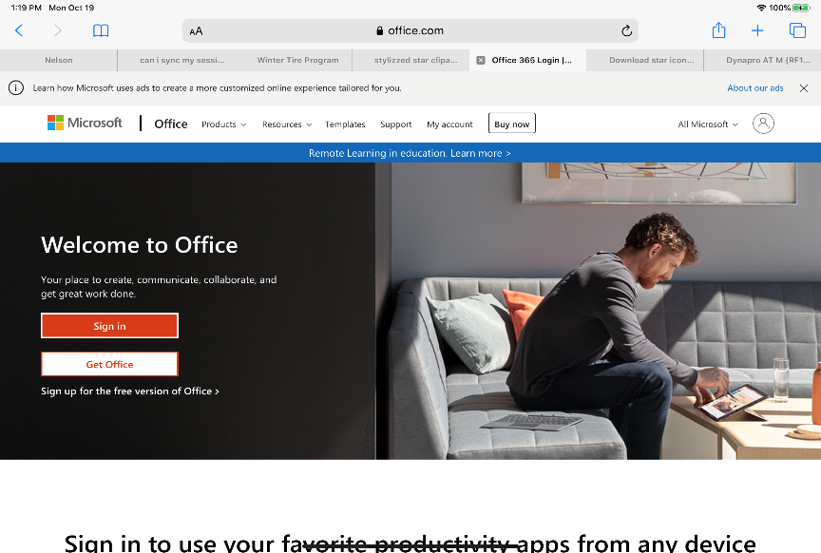
- You will be asked to sign in to access information.
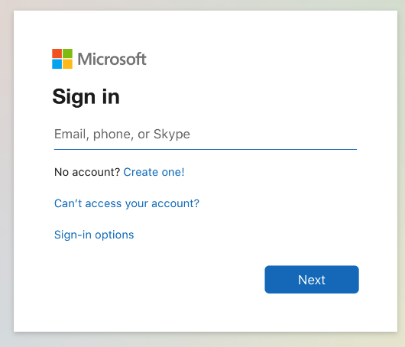
Here students will put in their username and password. It will be their last name and first
initial(s) and then their password. Your child’s teacher should have provided their information
with them. It will look like the following:

Username: LastNameFirst Initial(s) (Ex. FriesenW or PennerSt)
Password: XXXXXX (Unique for each student)

- Once you are logged in there should be a list of Office applications listed across the page or down the left-hand side. You will click on the TEAMS icon.
- You will be asked for the web version – you can access TEAMS while using the internet, or the desktop version – you will download TEAMS to your desktop and can use this as an app rather than going to the internet each time.
- You should now be into TEAMS

Joining a Teams meeting:
When it is time to join the meeting:
- Open your Teams app
- Select the CALENDAR button on the LEFT vertical pane.
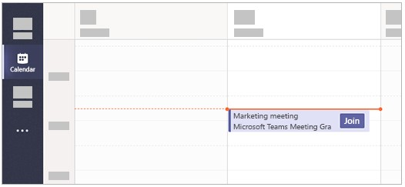
- In this calendar view you will see the meeting at the scheduled time. All you need to do is click
on the EVENT
- Then click on JOIN The JOIN button will be located on the meeting reminder in the calendar or at the TOP RIGHT of the screen.
- You will then have an opportunity to set up your speakers and microphone if necessary. Once you are ready, click on the “join now” button to join the meeting.

Good Meeting Practices:
- Mute your microphone if you are not speaking, this will prevent any unnecessary noise during the meeting.
- Use the blur feature to blur out your background for privacy if desired.
- Try not to speak over one another – rule of thumb is to allow others to speak first.
- Avoid multi-tasking while in a meeting.
- Be patient with one another as we learn how to use these new collaboration tools!

